6-2 Project One Submission: Network Modification Brief

Andree Salvo
Southern New Hampshire University
Cyb 210
Instructor: Bruce Gonzalez
2025
- Network Reconfigurations
Step A: Properly configure the VLAN for guest and video connections
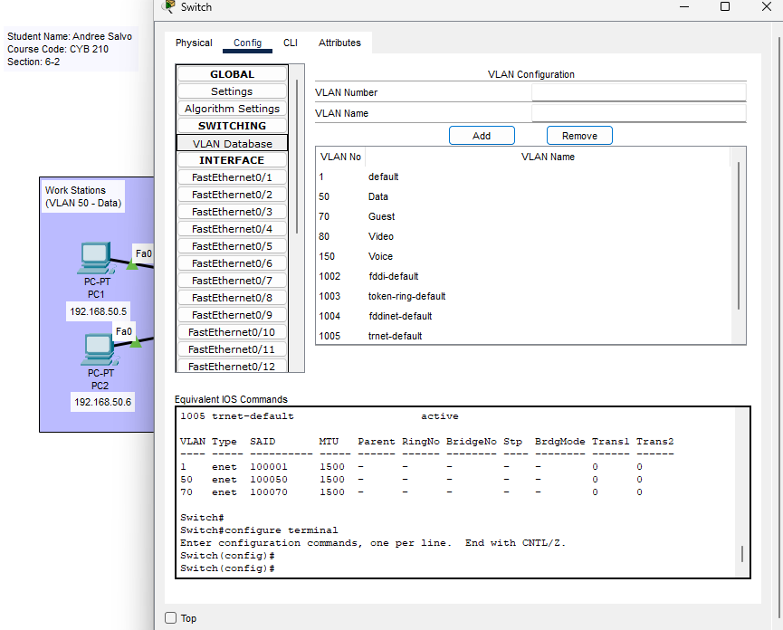 | - Opened the switch  - Clicked VLAN Database  - I added VLANS Guest 70 and Video 80. VLAN 50 and VLAN 150 were preset.

Step B: Properly configure the guest wireless network
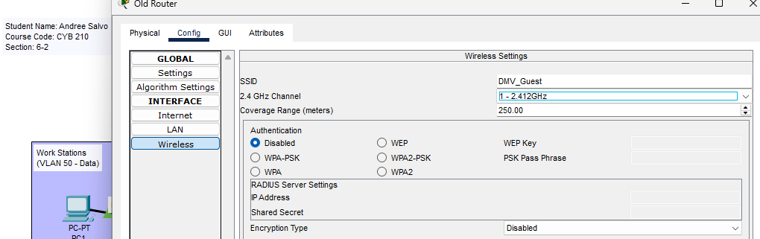
Explanation:
- Opened the OLD Router
- Click the config tab
- Select Wireless
- Renamed the “SSID” to “DMV_Guest”
- Authentication > I disabled

Step C: Make sure that devices are connected to the guest wireless network
Answer: they are connected
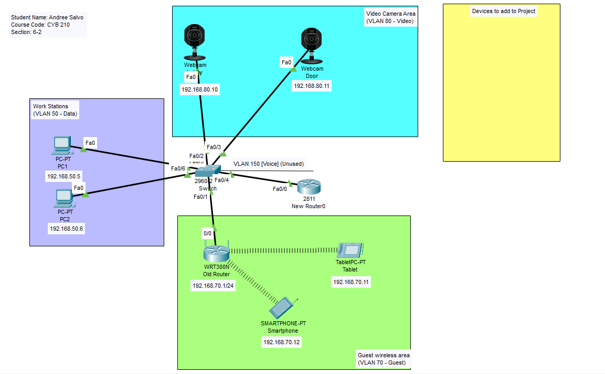

Step D: Make sure that cameras are connected to the video network
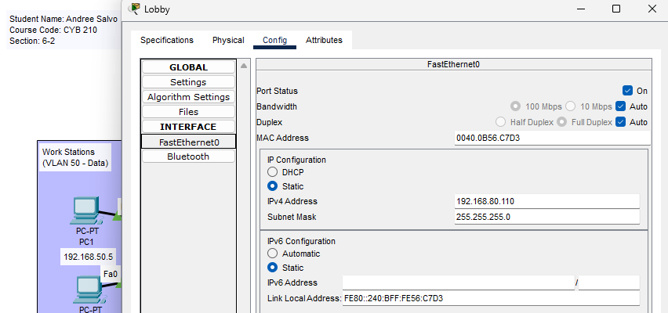
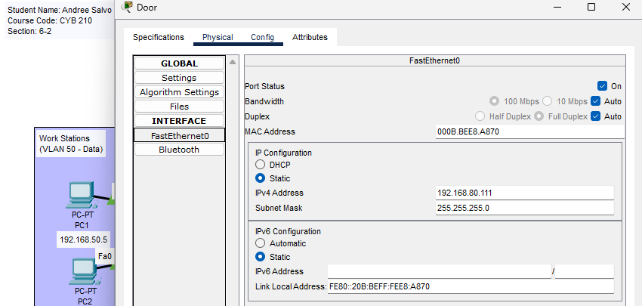
Answer: Cameras are connected!

Step E: Make sure that guest and video networks are properly segmented, ping tests that prove you have met this project requirement.
Answer: I pinged the cameras, and they are properly segmented!
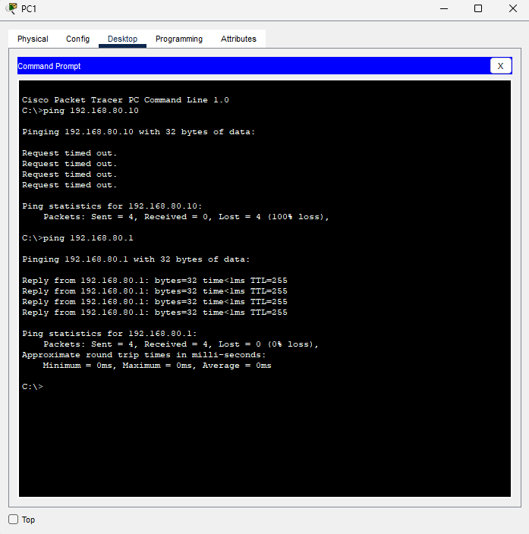
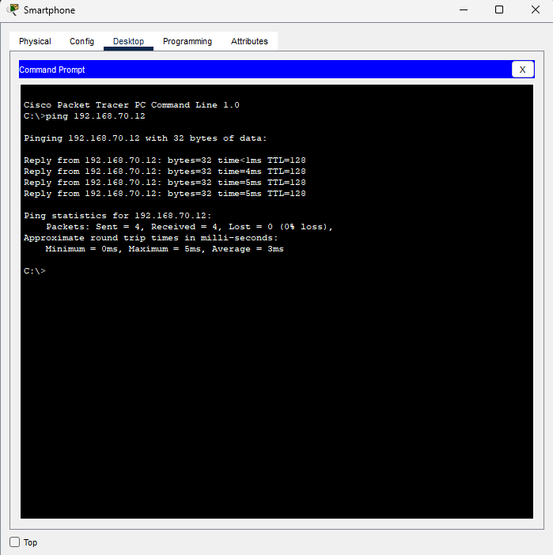
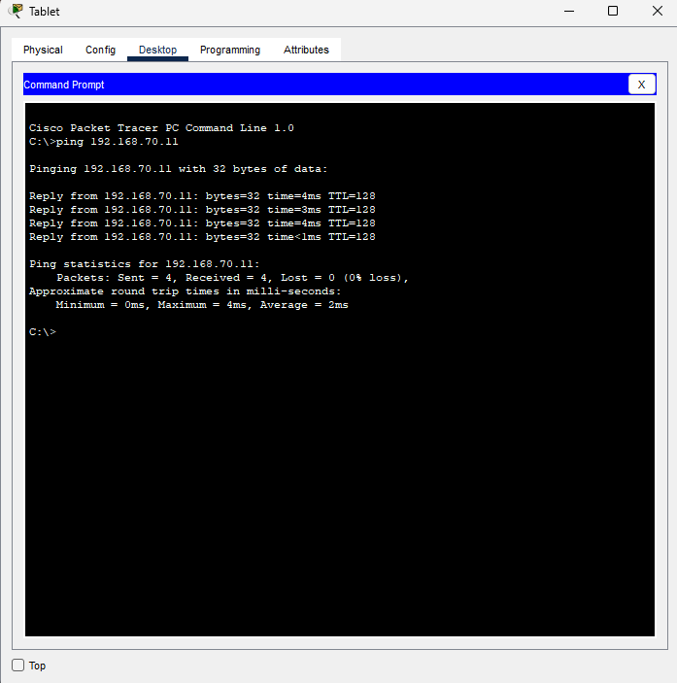

NOTE: I added a new router in Cisco Packet Tracer to enable communication between all VLANs.
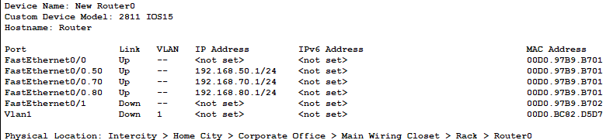

- Explanation of Network Segregation

- Describe how network traffic was segmented to meet the project requirements for guest and video connections.

Explanation: The switch segmented the network traffic by multiple VLAN databases. (1) VLAN 70, VLAN 70 is to be used for the guest, which connects to a wireless router, smartphone, and tablet. (2) VLAN 80 is for video. There were only two webcams for this scenario: "Lobby” and " Door.” (3) Lastly, VLAN 50 and 150 were already preset and were already segmented by two PCs. PC1 and PC2. VLAN 50 is data, and VLAN 150 is Voice. All four of these VLANs connect together by the switch, and all four work together differently.
- Explain how you considered the scalability of the guest wireless network in order to meet the project requirements (IP addressing, leasing, and so on).
Explanation: The scalability of meeting the project requirements allows up to 70 users to connect to a wireless network through the DHCP IP address. I did this from the Router’s GUI tab. Although the DMV may be slow, guests are not there for longer than 4 hours and cannot be connected to the guest network for a long.

